EXPERIMENT-5

ROLL NO: 240701238 NAME: Kathir Vikaas S

Conduct task analysis for an e-commerce app and document user flows.
AIM:
To understand and document the steps a user follows while using an e-commerce app.

PROCEDURE:
Step 1: Assigning Tasks
- Opening the app
- Checking user registration
- Creating account (if new user)
- Logging into the system
- Searching for product
- Viewing product details
- Adding product to cart
- Proceeding to checkout
- Entering delivery address
- Making payment
- Order confirmation

Step 2: Document User Flows
1. User Authentication
- Open App
- Check if user is registered
Flow:
Start → Open App → Is User Registered?
→ Yes → Enter Credentials → Login
→ No → Enter Details → Create Account

2. Home Navigation
- Login successful
- Navigate to home screen
Flow:
Login → Home Screen

3. Product Search and View
- Search product
- View product details
Flow:
Home Screen → Search Product → View Product

4. Add to Cart
- Select product
- Add to cart
Flow:
View Product → Add to Cart

5. Checkout Process
- Proceed to checkout
- Enter address
Flow:
Add to Cart → Proceed to Checkout → Enter Address

6. Payment Process
- Make payment
- Verify payment
Flow:
Enter Address → Payment

7. Order Completion
- Order confirmation
- End process
Flow:
Payment → Order Confirmation → End

- FLOWCHART:
Start → Open App → Is User Registered?
→ Yes → Enter Credentials → Login
→ No → Enter Details → Create Account
→ Home Screen → Search Product → View Product
→ Add to Cart → Proceed to Checkout → Enter Address
→ Payment → Order Confirmation → End
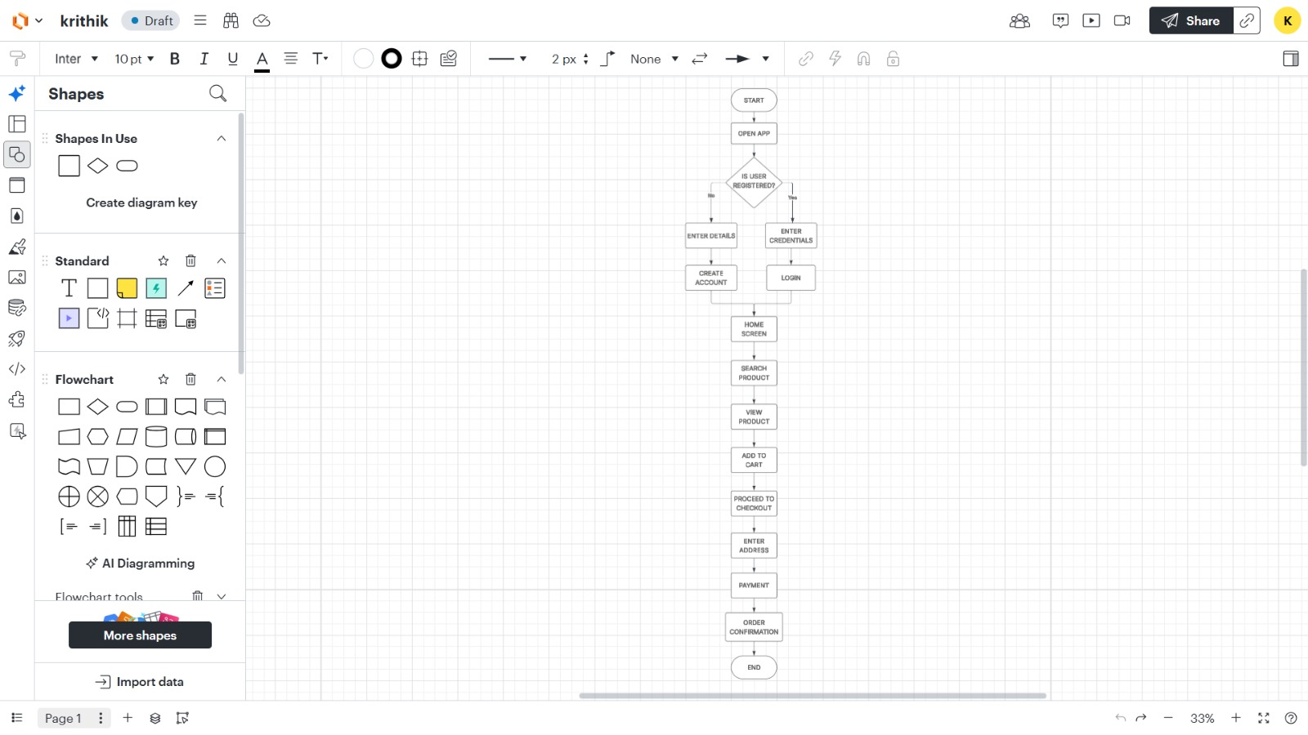

- CONCLUSION:
The flowchart clearly represents the complete user journey from opening the application to placing an order. It helps in understanding system functionality, improving user experience, and identifying key interaction points in the application.

